# **CTF Topic: Blue Button**

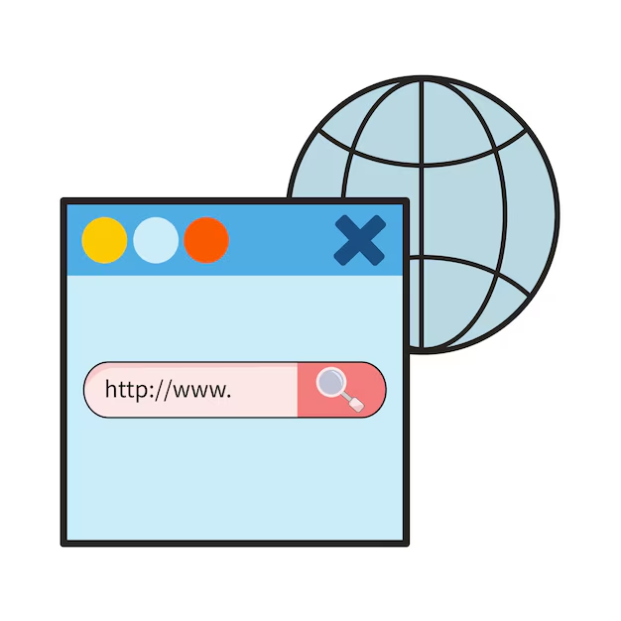

# **Introduction**

Blue Button the Webpage X-Ray is a browser extension that provides detailed information about a webpage's structure, including metadata, links, images, scripts, and stylesheets. It helps in understanding the components and resources used by a webpage.



# **2. Scenario**

You're competing in an exciting CTF event, and one of the challenges is to find a hidden Blue Button on a company's internal website. The button is said to reveal a crucial piece of information needed to complete the challenge.



# **Process to Follow while Performing CTF**

Step 1: Install the Blue Button:

<https://chromewebstore.google.com/detail/blue-button-the-webpage-x/ahbcoeleapdfhmlnjglbiaddohfncace>

Step 2: Open the Altoro Mutual website with the extension enabled: <https://altoro.testfire.net/>

Step 3: Use the extension to analyze the webpage and gather detailed information about its structure and resources.

# **Let's Begin The Challenge**

# **Question**

**Flag 1:** What is misc meta content type?

Answer: text/html; charset=iso-8859-1

Flag Captured.

**Flag 2:** what is meta description?

Answer: [null]

# **Hint**

